**Git tasks**

**I can win**

**1.**

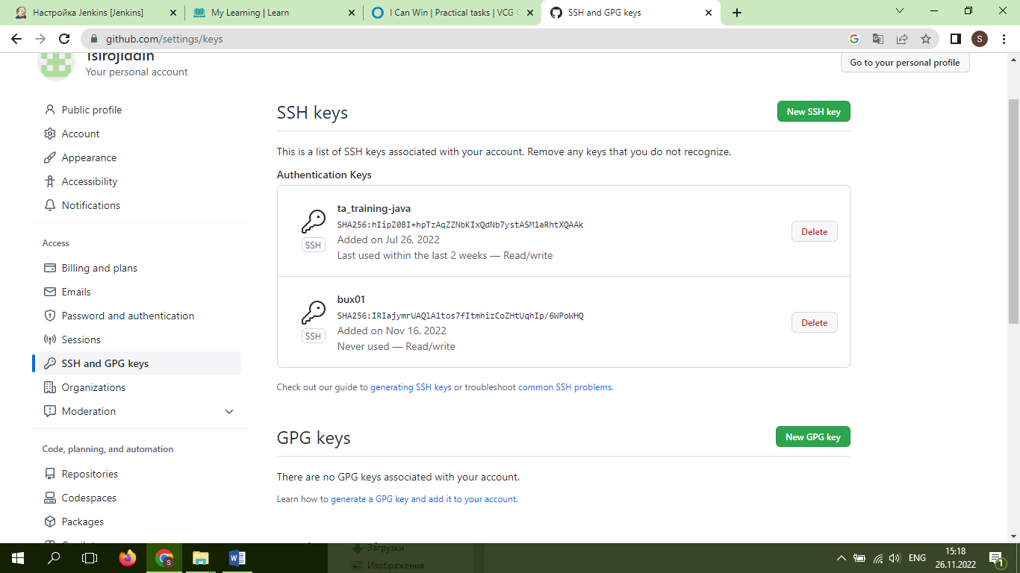

**2.**

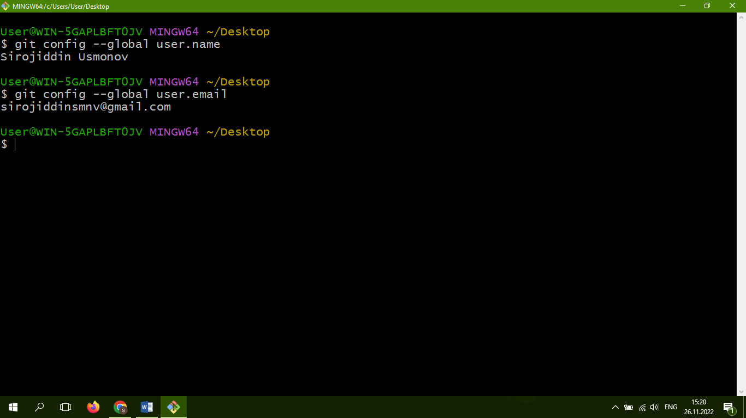

**3.**

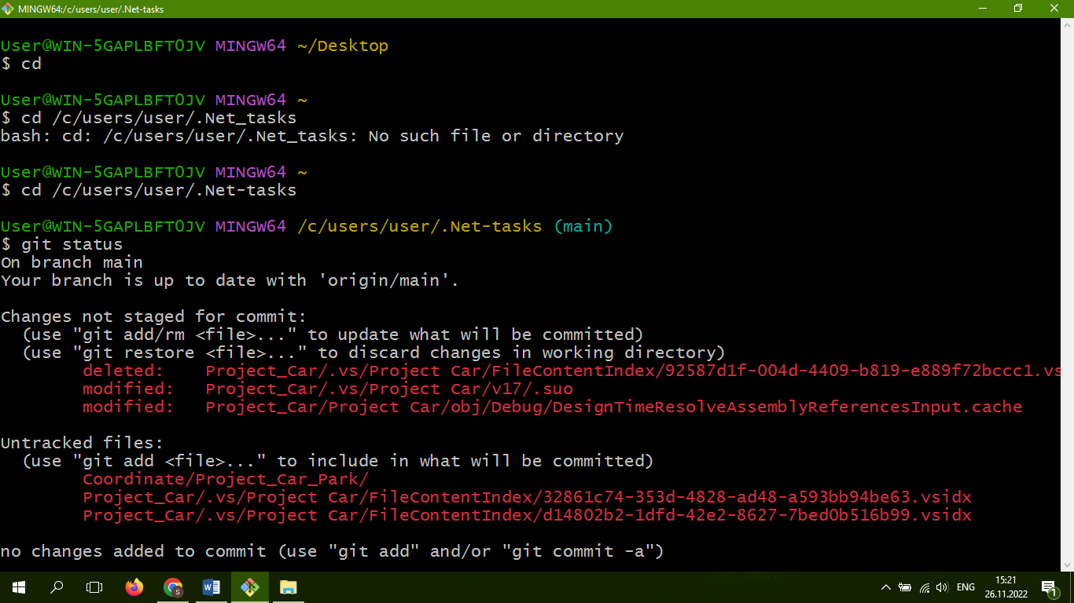

**4- I did it in java. Unfortunately I delete it from my git repository!!!**